Why Investing in Lahore Real Estate Is Smart in 2025

Introduction:
Lahore’s Real Estate Outlook in 2025
Lahore has always been one of Pakistan’s most dynamic and resilient real estate markets. As we enter 2025, the city continues to attract investors due to its strong economic activity, growing population, infrastructure expansion, and rising demand for quality residential and commercial developments. For both local and overseas investors, investing in Lahore real estate in 2025 is increasingly viewed as a smart and secure financial decision.
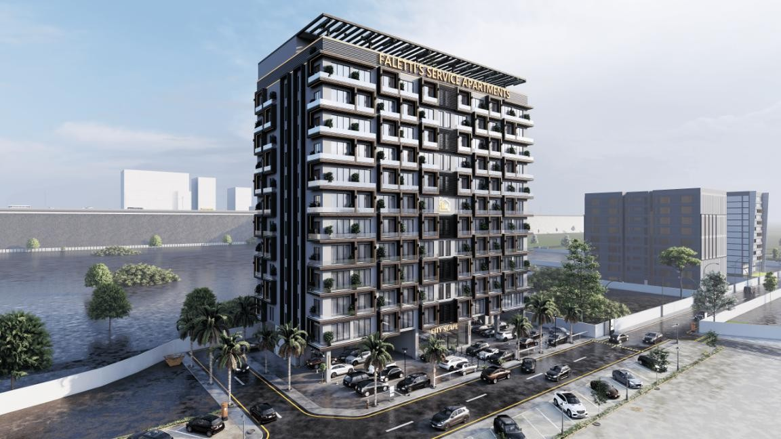

Unlike short-term investment options, real estate in Lahore offers long-term stability, capital appreciation, and consistent rental income. With urban development spreading across new areas and modern projects redefining living standards, the city is positioned for sustained growth. This blog explores in detail why investing in Lahore real estate is a smart choice in 2025, backed by market trends, demand factors, and investment potential.

Lahore’s Growing Importance as a Real Estate Hub

Economic and Commercial Significance of Lahore

Lahore is not just a cultural capital—it is a major economic engine of Pakistan. The city hosts thousands of businesses, corporate offices, industrial zones, educational institutions, and healthcare facilities. This economic diversity fuels continuous demand for residential and commercial properties.

In 2025, Lahore’s expanding economy continues to support:

- Job creation
- Business expansion
- Commercial real estate demand

This makes property investment in Lahore less volatile compared to smaller or less- developed cities.

Urban Expansion and Planned Development
Lahore is expanding both horizontally and vertically. New housing societies, mixed- use developments, and high-rise projects are reshaping the skyline. Planned development ensures better infrastructure, organized communities, and long-term sustainability.

These factors directly contribute to rising property values and improved investor confidence.

Infrastructure Development Driving Property Value Growth

Major Road Networks and Connectivity
One of the strongest reasons why investing in Lahore real estate is a smart choice in 2025 is the city’s continuous infrastructure improvement. New road networks, flyovers, underpasses, and ring-road extensions are improving connectivity across Lahore.

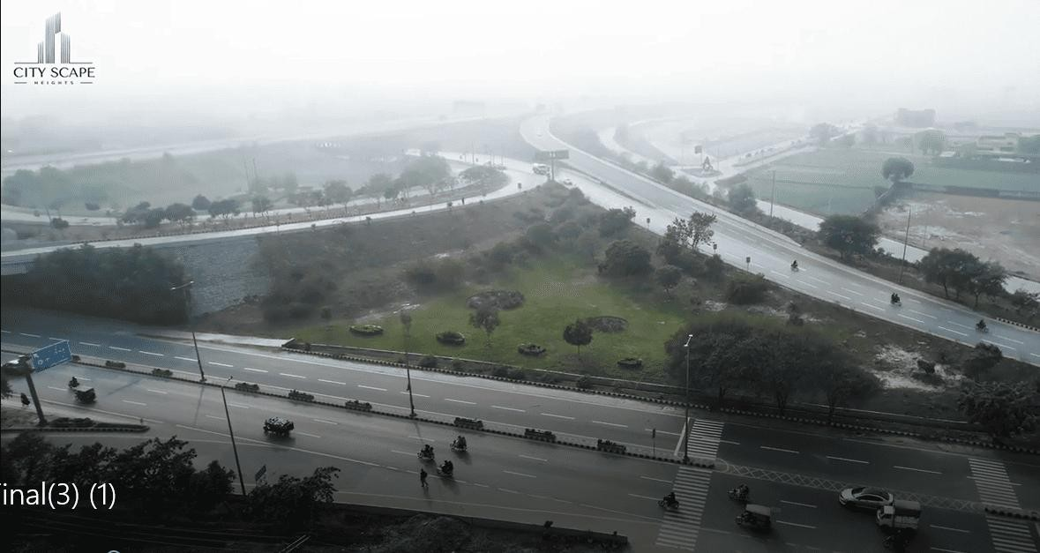

Improved infrastructure:
- Reduces travel time
- Enhances accessibility
- Increases property demand in surrounding areas

Historically, areas connected to major road projects experience faster appreciation.

Public Transport and Urban Mobility
Public transport initiatives have also played a role in increasing property value. Areas near transport corridors are becoming attractive for residents and investors alike, supporting both resale and rental demand.

Population Growth and Rising Housing Demand

Urban Migration and Lifestyle Shift
Lahore continues to attract people from smaller cities and rural areas due to better job opportunities, education, healthcare, and lifestyle options. This migration results in a constant need for housing.

In 2025, population-driven demand remains one of the strongest pillars of Lahore’s real estate market.

Limited Land Supply in Prime Locations

As demand increases and land availability becomes limited in prime areas, property prices naturally rise. Investors who enter the market early benefit from long-term capital gains.

Strong Rental Market and Passive Income Potential

High Rental Demand Across Key Areas
Rental demand in Lahore is consistently strong, especially in:

- Business districts
- Areas near universities and hospitals
- Central and well-connected locations

Professionals, students, families, and business travelers all contribute to this demand.

Service Apartments and Modern Living Trends
Service apartments and apartment living are becoming increasingly popular in Lahore. These properties offer higher rental yields and attract tenants seeking convenience, security, and modern amenities.
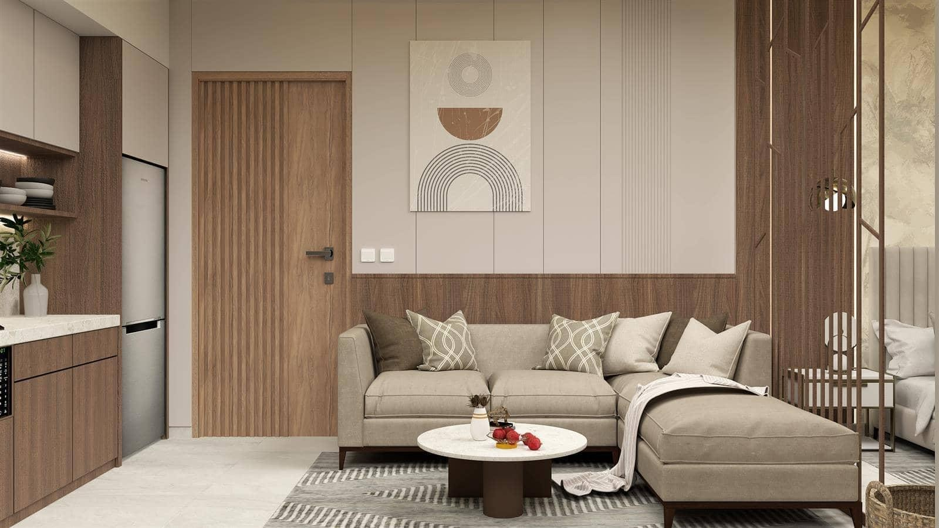
For investors, this trend creates an opportunity for steady monthly income alongside property appreciation.

Variety of Real Estate Investment Options

Residential Property Investments
Residential properties remain a preferred choice for long-term investors. Options include:

- Plots
- Houses
- Apartments

Each category caters to different budgets and investment goals.

Commercial Real Estate Opportunities
Commercial properties such as shops, offices, and plazas offer higher rental yields and long-term lease stability. In 2025, commercial activity in Lahore continues to expand, strengthening demand for such assets.

Mixed-Use and High-Rise Developments
Mixed-use developments combine residential, commercial, and recreational spaces, making them attractive for modern investors. These projects often experience faster appreciation due to their integrated lifestyle approach.

Benefits of Investing in Under-Construction Projects

Lower Entry Prices and Flexible Payment Plans
Under-construction properties offer investors the chance to enter at a lower price compared to completed projects. Developers often provide flexible installment plans, making investment more accessible.

Higher Appreciation Potential
As construction progresses and the project nears completion, property values typically increase. This makes early-stage investment particularly attractive in 2025.

Market Transparency and Improved Regulations

Safer Investment Environment

Over time, Lahore’s real estate market has become more organized. Approved projects, proper documentation, and increased awareness among buyers have reduced risks.

This improvement in transparency is another reason why investing in Lahore real estate is a smart choice in 2025, especially for first-time investors.

Developer Accountability and Quality Focus
Developers are now focusing more on construction quality, timely delivery, and transparent communication. This shift benefits both investors and end-users.

Overseas Pakistani Investment Interest

Lahore as a Preferred Destination
Overseas Pakistanis continue to invest heavily in Lahore due to emotional attachment, financial security, and strong returns. Property investment also acts as a hedge against currency fluctuation.

Ease of Remote Investment
Digital platforms, virtual site visits, and regular progress updates have made it easier than ever for overseas investors to invest in Lahore real estate with confidence.

Capital Appreciation and Long-Term Growth

Historical Performance of Lahore Real Estate
Historically, Lahore has delivered consistent capital appreciation. Prime locations
and quality developments have shown steady price growth over the years.

Factors Supporting Future Appreciation
In 2025, appreciation is supported by:

- Rising construction costs
- Infrastructure expansion
- Increasing demand for quality projects

These fundamentals make Lahore a strong long-term investment market.

Real Estate as Protection Against Inflation

Asset Security in Uncertain Times
Real estate remains one of the most reliable assets to protect wealth against inflation. Rental income and property values generally rise over time, preserving purchasing power.

In 2025, many investors are choosing property over volatile investment options for long-term financial security.

Lifestyle-Oriented Developments Increasing Value

Modern Amenities and Smart Living
Today’s buyers and tenants seek more than just space. Modern projects offer:

- Security systems
- Parking facilities
- Elevators and backup power
- Recreational and communal areas

Such features increase rental demand and resale value.

Changing Buyer Preferences
The shift toward apartment living and managed developments is reshaping Lahore’s real estate landscape, creating new opportunities for investors.

Key Factors to Consider Before Investing in Lahore

Location Selection
Choosing the right location remains critical. Areas with strong connectivity, infrastructure development, and commercial activity offer better returns.

Developer Reputation

Investing with a reputable developer reduces risk and ensures construction quality and timely delivery.

Investment Goals
Whether the goal is rental income, resale profit, or long-term holding, aligning strategy with the right property type is essential.

Conclusion:
Why 2025 Is the Right Time to Invest in Lahore Real Estate
To summarize, why investing in Lahore real estate is a smart choice in 2025 comes down to strong fundamentals—urban growth, infrastructure development, rising demand, rental income potential, and long-term appreciation.

Lahore continues to offer stability in an evolving market, making it suitable for both conservative and growth-oriented investors. With the right planning, location, and project selection, real estate investment in Lahore can deliver lasting financial rewards.

